**UML DIAGRAMS**

1. **LIBRARY MANAGEMENT SYSTEM**

**1A) CLASS DIAGRAM:**

**1B) USE CASE DIAGRAM**

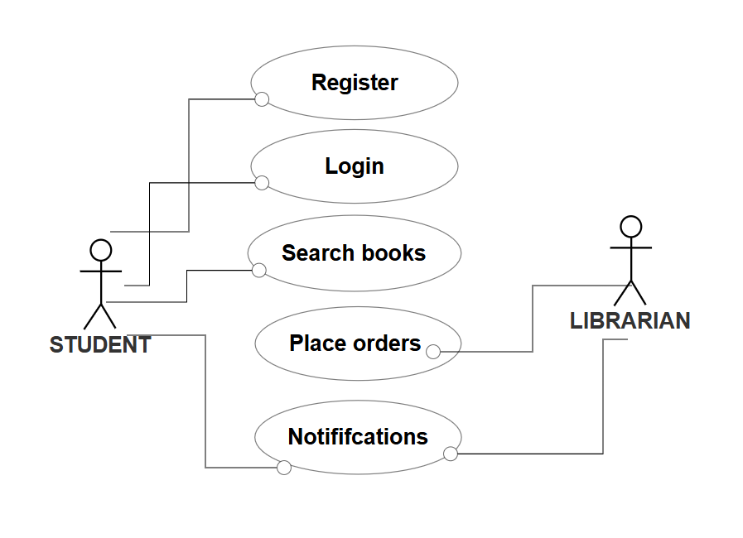

**1C) SEQUENCE DIAGRAM**

**1D) STATE ACTIVITY DIAGRAM:**

**1E) STATE CHART DIAGRAM:**

1. **ONLINE HOSPITAL MANAGEMENT SYSTEM**

**2A) CLASS DIAGRAM:**

**2B) USE CASE DIAGRAM:**

**1C) SEQUENCE DIAGRAM**

**1D) ACTIVITY DIAGRAM:**

**1E) OBJECT DIAGRAM:**

**3. JAVA BASIC PROGRAMS**

1)

**AIM :** To generate a program to print area of triangle

**ALGORITHM**:

* 1. Start.
  2. Accept base and height values.
  3. Compute the area using the formula: Area=1/2×base×height
  4. Display the result.
  5. End.

**CODE :**

import java.util.Scanner;

class Triangle{

public static void main(String[] args) { Scanner scan = new Scanner(System.in);

System.out.print("Enter the base of the triangle: "); double base = scan.nextDouble(); System.out.print("Enter the height of the triangle: "); double height = scan.nextDouble();

double area = 0.5 * base * height; System.out.println("The area of the triangle is: " +

area);

scan.close();

}

}

**OUTPUT:**

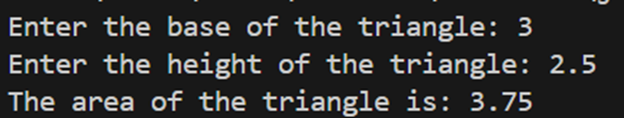

1. **AIM**: To Calculate average of 3 numbers

**ALGORITHM:**

1. Start.
2. Accept three numbers from the user.
3. Compute the average using the formula: average=num1+num2+num3/ 3
4. Display the result.
5. End.

**CODE:**

import java.util.Scanner; class average{

public static void main(String[] args) { Scanner scan = new Scanner(System.in);

System.out.print("Enter the first number: "); int num1 = scan.nextInt(); System.out.print("Enter the second number: "); int num2 = scan.nextInt(); System.out.print("Enter the third number: "); int num3 = scan.nextInt();

double average = (num1 + num2 + num3) / 3; System.out.println("The average of the three numbers is: " +

average);

scan.close();

}

}

**OUTPUT:**

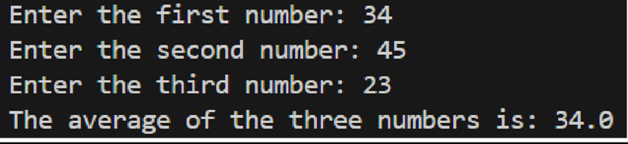

1. **AIM**: To determine a student’s grade based on marks using conditional statements.

**ALGORITHM:**

1. Start.
2. Accept the marks (out of 100) from the user.
3. Use if-else conditions:

* 90–100 → Grade A
* 80–89 → Grade B
* 70–79 → Grade C
* 60–69 → Grade D
* 50–59 → Grade E
* Below 50 → Grade F

1. Display the grade.
2. End.

**CODE:**

import java.util.Scanner; class grade{

public static void main(String[] args) { Scanner scan = new Scanner(System.in);

System.out.print("Enter the student's marks (out of 100): ");

int marks = scan.nextInt(); char grade=' ';

if (marks >= 90 && marks <= 100) { grade = 'A';

} else if (marks >= 80) { grade = 'B';

} else if (marks >= 70) { grade = 'C';

} else if (marks >= 60) { grade = 'D';

} else if (marks >= 50) { grade = 'E';

} else if (marks >= 0) { grade = 'F';

}

else {

System.out.println("Invalid input");

}

System.out.println("The student's grade is: " + grade); scan.close(); }

}

**OUTPUT :**

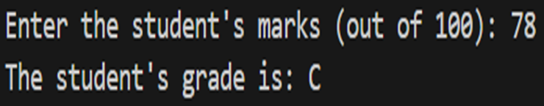

1. **AIM:** To categorize a person as Child, Teenager, Adult, or Senior Citizen based on their age.

**ALGORITHM :**

1. Start.
2. Accept age as input.
3. Use if-else conditions to categorize:

* 0–12 → Child
* 13–19 → Teenager
* 20–59 → Adult
* 60+ → Senior Citizen

1. Display the category.
2. End**.**

**CODE:**

import java.util.Scanner; class category{

public static void main(String[] args) { Scanner scan = new Scanner(System.in);

System.out.print("Enter the person's age: "); int age = scan.nextInt();

String category; if (age < 0) {

category = "Invalid age entered.";

} else if (age <= 12) { category = "Child";

} else if (age <= 19) { category = "Teenager";

} else if (age <= 59) { category = "Adult";

} else {

category = "Senior Citizen";

}

System.out.println("The person belongs to the category: " + category);

scan.close();

}

}

**OUTPUT:**

1. **AIM :** To generate Java program to calculate electricity bill

**ALGORITHM:**

* 1. Start.
  2. Accept the number of units consumed.
  3. Compute the bill using conditions:
* Up to 100 units → ₹1.50 per unit.
* 101–300 units → ₹2.00 per unit (extra for units above 100).
* Above 300 units → ₹3.00 per unit (extra for units above 300).
  1. Add a fixed service charge of ₹50.
  2. Display the total bill amount.
  3. End.

**CODE:**

import java.util.Scanner;

class bill{

public static void main(String[] args) { Scanner scan = new Scanner(System.in);

System.out.print("Enter the number of units consumed: ");

double units = scan.nextDouble(); double billAmount;

if (units <= 100) { billAmount = units * 1.50;

} else if (units <= 300) {

billAmount = (100 * 1.50) + ((units - 100) * 2.00);

} else {

billAmount = (100 * 1.50) + (200 * 2.00) + ((units -

300) * 3.00);

}

double serviceCharge = 50.00; billAmount += serviceCharge;

System.out.println("Total Bill Amount: Rs. " + billAmount);

scan.close();

}

}

**OUTPUT :**

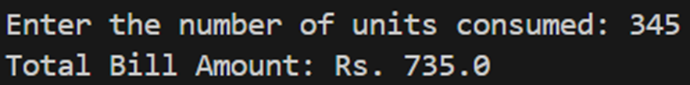

1. **AIM:** To find the odd numbers in a range between a upper and a lower limit

**ALGORITHM:**

Start

Initialize Scanner to take user input.

Prompt User to enter the lower limit.

Read the lower limit and store it in lower.

Prompt User to enter the upper limit.

Read the upper limit and store it in upper.

Loop from lower to upper:

If the current number is odd (number % 2 != 0), print it.

Close the Scanner to prevent resource leaks.

End

**CODE:**

import java.util.*;

public class OddNumbersInRange {

public static void main(String[] args) {

Scanner scanner = new Scanner(System.in);

System.out.print("Enter the lower limit: ");

int lower = scanner.nextInt();

System.out.print("Enter the upper limit: ");

int upper = scanner.nextInt();

for (int i = lower; i <= upper; i++) {

if (i % 2 != 0) {

System.out.println(i);

}

}

scanner.close();

    }

}

**OUTPUT:**

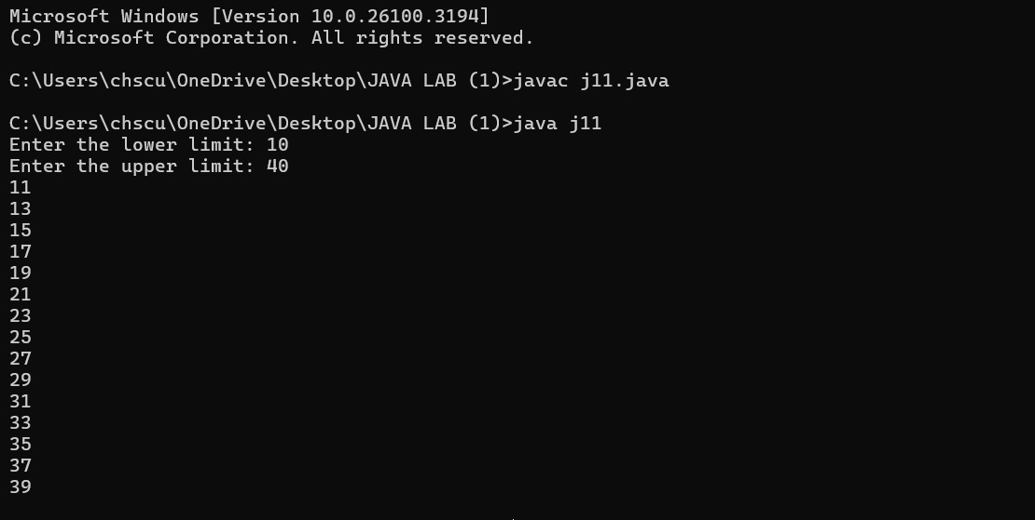

1. **AIM:** To check wheather the number is a palindrome or not

**ALGORITHM:**

1. Start
2. Initialize Scanner to take user input.
3. Prompt the user to enter a number.
4. Read the number and store it in number.
5. Store the original number in originalNumber.
6. Initialize reversedNumber to 0.
7. Reverse the number using a loop:
   * While number is not 0:
     + Extract the last digit (digit = number % 10).
     + Append digit to reversedNumber (reversedNumber = reversedNumber * 10 + digit).
     + Remove the last digit (number = number / 10).
8. Compare originalNumber and reversedNumber:
   * If they are equal, print "originalNumber is a palindrome."
   * Otherwise, print "originalNumber is not a palindrome."
9. Close the Scanner.
10. End

**CODE:**

import java.util.*;

public class PalindromeCheck {

public static void main(String[] args) {

Scanner scanner = new Scanner(System.in);

System.out.print("Enter a number: ");

int number = scanner.nextInt();

int originalNumber = number;

int reversedNumber = 0;

while (number != 0) {

int digit = number % 10;

reversedNumber = reversedNumber * 10 + digit;

number /= 10;

}

if (originalNumber == reversedNumber) {

System.out.println(originalNumber + " is a palindrome.");

} else {

System.out.println(originalNumber + " is not a palindrome.");

}

scanner.close();

    }

}

**OUTPUT:**

1. **AIM:** To find the factorial of a given number

**ALGORITHM:**

**CODE:**

import java.util.*;

public class Factorial {

public static void main(String[] args) {

Scanner scanner = new Scanner(System.in);

System.out.print("Enter a number: ");

int number = scanner.nextInt();

int factorial = 0;

for (int i = 1; i <= number; i++) {

factorial *= i;

}

System.out.println("Factorial of " + number + " is " + factorial);

scanner.close();

    }

}

**OUTPUT:**

1. **AIM**: to calculate the number is even or odd

**ALGORITHM:**

* 1. Start.
  2. Import Scanner for user input.
  3. Prompt the user to enter a number.
  4. Use the modulus operator % to check if the number is divisible by 2.
* If number % 2 == 0, print "Even".
* Otherwise, print "Odd".
  1. End.

**CODE:**

import java.util.Scanner;

public class EvenOddCheck {

public static void main(String[] args) {

Scanner sc = new Scanner(System.in);

System.out.print("Enter a number: ");

int num = sc.nextInt();

if (num % 2 == 0)

System.out.println(num + " is Even.");

else

System.out.println(num + " is Odd.");

sc.close();

}

}

**OUTPUT:**

1. **AIM:** To print Fibonacci Series

**ALGORITHM :**

* 1. Start.
  2. Import Scanner for user input.
  3. Prompt the user to enter the number of terms.
  4. Initialize first = 0, second = 1.
  5. Use a loop to print Fibonacci numbers:
* Compute the next term by adding the last two terms.
* Print each term.
  1. End.

CODE:

import java.util.Scanner;

public class Fibonacci {

public static void main(String[] args) {

Scanner sc = new Scanner(System.in);

System.out.print("Enter number of terms: ");

int terms = sc.nextInt();

int first = 0, second = 1, next;

System.out.print("Fibonacci Series: " + first + " " + second);

for (int i = 2; i < terms; i++) {

next = first + second;

System.out.print(" " + next);

first = second;

second = next;

}

sc.close();

}

}

**OUTPUT:**

**4. INHERITANCE**

**4a) Single inheritance**

1. **To generate pay slips for calculating salary details of the employess working along with it displaying their details .**

**AIM :** To develop a Java program that calculates the salary of employees based on the number of days worked and displays their details**.**

**ALGORITHM:**

1. Start.
2. Create a class salary with a method cal(int n) to calculate the salary.
3. Create a class details that extends salary and defines the method display(...) to show employee details.
4. In the main method:
   * Accept employee name, ID, designation, and number of days worked.
   * Compute the salary using cal(n).
   * Display all details using the display() method.
5. End

**CODE :**

import java.util.Scanner;

class salary{

int n; double sal;

double cal(int n){

sal = n*2500;

return sal;

}}

class details extends salary{

String na ; int eid; String d; int n;

void display(String na,int eid,String d,int n,double sal){

System.out.println("Name"+na);

System.out.println("Employee id:"+eid);

System.out.println("Designation:"+d);

System.out.println("Number of days worked:"+n);

System.out.println("SALARY:"+sal);

}}

public class j3{

public static void main(String[] args)

{

Scanner obj = new Scanner(System.in);

System.out.println("Enter your name");

String na = obj.nextLine();

System.out.println("Enter employee id");

int eid = obj.nextInt();

System.out.println("Enter designation");

obj.nextLine();

String d = obj.nextLine();

System.out.println("Enter Number of days worked:");

int n = obj.nextInt();

details de = new details();

double sal = de.cal(n);

de.display(na,eid,d,n,sal);

obj.close();

}

}

**OUTPUT:**

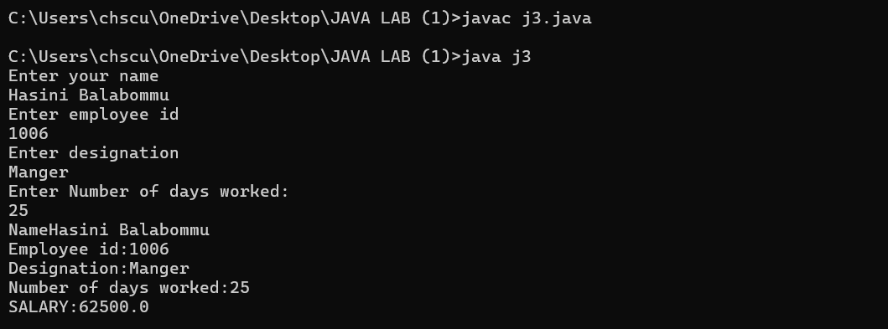

1. To **Write a Java program that demonstrates the use of classes and objects. This program defines a class called Person with attributes like name, age, and a method displayInfo() to display the information of a person.**

**AIM:** To create a Java program that demonstrates the use of classes and objects using a Person class.

**ALGORITHM :**

1. Start.
2. Define a class person with a method displayinfo(String name, int age).
3. In the main method:

* Accept user input for name and age.
* Create an object of person class.
* Call displayinfo() to display user details.

1. End.

**CODE :**

import java.util.Scanner; class person{

void displayinfo (String name,int age){ System.out.println("name: "+name); System.out.println("age: "+age);

}

}

public class human{

public static void main(String []args){ Scanner scan=new Scanner(System.in); System.out.print("Enter your name: "); String name=scan.nextLine(); System.out.print("Enter your age: "); int age=scan.nextInt();

person p=new person(); p.displayinfo(name,age);

}

}

**OUTPUT:**

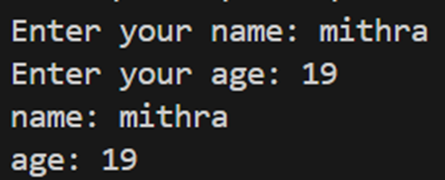

**4b) Multilevel Inheritance**

**Q no 1) AIM: To display the persons details using multilevel inheritance**

**ALGORITHM:**

1. Start
2. Define Person class
   * Declare attributes: name (String) and age (int).
   * Define method display(String name, int age) to print employee name and age.
3. Define Employee class (Inherits from Person)
   * Declare attribute: sal (double).
   * Define method display(String name, int age, double sal) to print employee name, age, and salary.
4. Define Manager class (Inherits from Employee)
   * Declare attribute: dept (String).
   * Define method display(String name, int age, double sal, String dept) to print employee name, age, salary, and department.
5. Define ml1 class with main method
   * Create a Scanner object to read user input.
   * Prompt the user to enter:
     + Name (String)
     + Age (int)
     + Salary (double)
     + Department (String)
   * Store the input values.
6. Create an object of Person class
   * Call display(name, age) method to print name and age.
7. Create an object of Manager class
   * Call display(name, age, sal, dept) method to print name, age, salary, and department.
8. End

**CODE:**

import java.util.Scanner;

class Person{

String name;

int age;

void display(String name,int age){

System.out.println("Employee name:"+name);

System.out.println("AGE:"+age);

}

}

class Employee extends Person{

double sal;

void display(String name,int age,double sal){

System.out.println("Employee name:"+name);

System.out.println("AGE:"+age);

System.out.println("Salary:"+sal);

}

}

class Manager extends Employee{

String dept;

void display(String name,int age,double sal,String dept){

System.out.println("Employee name:"+name);

System.out.println("AGE:"+age);

System.out.println("Salary:"+sal);

System.out.println("Department:"+dept);

}

}

public class ml1{

public static void main(String[] args){

Scanner obj = new Scanner(System.in);

System.out.println("Enter your name");

String name = obj.nextLine();

System.out.println("Enter your age");

int age = obj.nextInt();

System.out.println("Enter your Salary");

double sal = obj.nextDouble();

System.out.println("Enter your department");

obj.nextLine();

String dept = obj.nextLine();

Person p = new Person();

p.display(name,age);

Manager m = new Manager();

m.display(name,age,sal,dept);

}

}

**OUTPUT:**

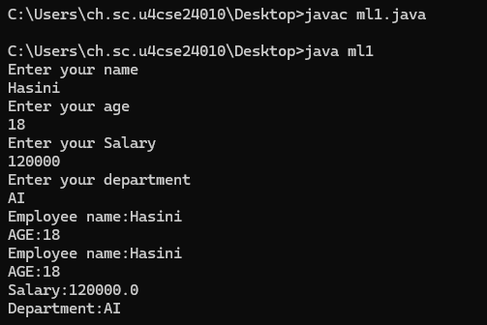

**Q no 2) To display various bank details such as balance rate of interest using methods such as withdraw , deposit etc… using multiple inheritance**

**AIM:**

ALGORITHM:

* 1. Start
  2. Define Bankaccount class
  3. Declare attributes:
  + ano (int) → Account number
  + b (double) → Balance
  + roi (float) → Rate of interest
  + amt (double) → Deposit amount
  1. Define method deposit(double b, double amt)
  2. Add amt to b (balance).
  3. Print the updated balance.
  4. Define Savingsaccount class (Inherits from Bankaccount)
* Declare attribute: w (double) → Withdrawal amount
* Define method withdraw(double b, double w)
  1. Check if w > b (withdrawal amount is greater than balance)
     1. If true, print "balance not sufficient".
     2. Else, subtract w from b and print the updated balance.
  2. Define fixeddeposit class (Inherits from Savingsaccount)
* Define method getinterest(float r, double b)
  + Calculate interest as r = (float)(b * 0.77).
  + Return the interest amount.
  1. Define ml2 class with main method
* Create a Scanner object to read user input.
* Prompt the user to enter:
  + Balance in account (b).
  + Amount to deposit (amt).
  + Amount to withdraw (w).
* Store the input values.
  1. Create an object of Bankaccount
* Call deposit(b, amt) to add deposit amount to balance and print it.
  1. Create an object of Savingsaccount
* Call withdraw(b, w) to perform withdrawal and print the new ba**lance.**
  1. End

**CODE:**

import java.util.Scanner;

class Bankaccount{

int ano;

double b;

float roi;

double amt;

void deposit(double b,double amt){

b=b+amt;

System.out.println("BALANCE:"+b);

}

}

class Savingsaccount extends Bankaccount{

double w;

void withdraw(double b,double w){

if(w>b){

System.out.println("balance not sufficient");

}

else{

b=b-w;

System.out.println("BALANCE:"+b);

}

}

}

class fixeddeposit extends Savingsaccount{

float getinterest(float r,double b){

r=(float)(b*0.77);

return r;

}

}

public class ml2{

public static void main(String[] args){

Scanner obj = new Scanner(System.in);

System.out.println("Enter the balance in your acount");

double b = obj.nextDouble();

System.out.println("Enter the amount you want to deposit");

double amt = obj.nextDouble();

System.out.println("Enter the amount you want to withdraw");

double w = obj.nextDouble();

Bankaccount ba = new Bankaccount();

ba.deposit(b,amt);

Savingsaccount s = new Savingsaccount();

s.withdraw(b,w);

}

}

**OUTPUT:**

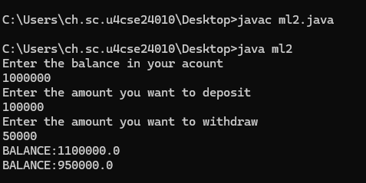

**4c) Hierarchical Inheritance**

**Q no 1)To create a base class shape and subclasses rectangle and circle and applying the methods such as calculating area and perimeter**

**AIM :** To create a base class Shape and subclasses Rectangle and Circle, implementing methods to calculate area and perimeter.

**ALGORITHM :**

1. Start.
2. Create a class Shape with default methods for calculateArea() and calculatePerimeter().
3. Define a subclass Rectangle with length and width attributes:
   * Override methods to compute area and perimeter.
4. Define a subclass Circle with radius:
   * Override methods for area and perimeter.
5. In main:
   * Take user input for dimensions.
   * Create objects of Rectangle and Circle.
   * Display computed area and perimeter.
6. End.

**CODE :**

import java.util.Scanner;

class Shape {

double calculateArea() {

return 0;

}

double calculatePerimeter() {

return 0; } }

class Rectangle extends Shape {

double length, width;

Rectangle(double l, double w) {  
 length = l;  
 width = w;  
}

double calculateArea() {

return length * width;

} double calculatePerimeter() {

return 2 * (length + width

} }

class Circle extends Shape {

double radius; double pi = 3.14159;

Circle(double r) {  
 radius = r;  
}

double calculateArea() {

return pi * radius * radius;

}

double calculatePerimeter() {

2 * pi * radius;

} }

class j4 {

public static void main(String[] args) {

Scanner obj = new Scanner(System.in);

System.out.println("Enter the length");

double l = obj.nextDouble();

System.out.println("Enter breadth");

double w = obj.nextDouble();

System.out.println("Enter radius");

double r = obj.nextDouble();

Shape rect = new Rectangle(l,w);

System.out.println("Rectangle Area: " + rect.calculateArea()); System.out.println("Rectangle Perimeter: " + rect.calculatePerimeter());

Shape circ = new Circle(r); System.out.println("\nCircle Area: " + circ.calculateArea()); System.out.println("Circle Perimeter: " + circ.calculatePerimeter());

}

}

OUTPUT:

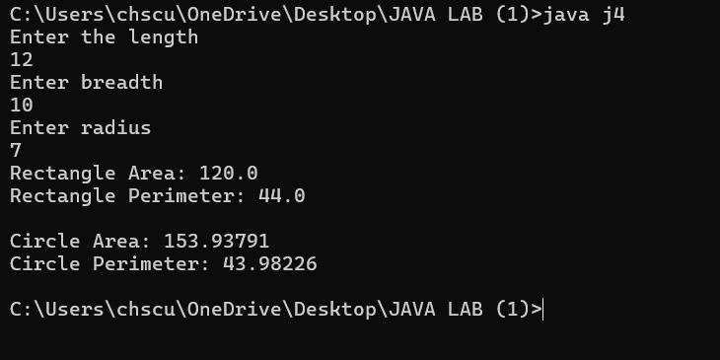

**4d) Multiple inheritance**

**Q no 1)**

**AIM:** Define two interfaces Flyable and Swimmable. Create a class Bird implementing Flyable and a class Duck implementing both Flyable and Swimmable**.**

**ALGORITHM:**

1. Define the Interfaces:
   * Create an interface Flyable with a method fly().
   * Create an interface Swimmable with a method swim().
2. Create the Bird class:
   * Implement the Flyable interface.
   * Define the fly() method to print "Bird is flying.".
3. Create the Duck class:
   * Implement both Flyable and Swimmable interfaces.
   * Define the fly() method to print "Duck is flying.".
   * Define the swim() method to print "Duck is swimming.".
4. Create the Main Class (MultipleInheritanceExample):
   * Instantiate an object of Bird and call the fly() method.
   * Instantiate an object of Duck and call both fly() and swim() methods.
5. End the program**.**

**CODE:**

interface Flyable {

void fly();

}

interface Swimmable {

void swim();

}

class Bird implements Flyable {

public void fly() {

System.out.println("Bird is flying.");

}

}

class Duck implements Flyable, Swimmable {

public void fly() {

System.out.println("Duck is flying.");

}

public void swim() {

System.out.println("Duck is swimming.");

}

}

public class m1 {

public static void main(String[] args) {

Bird bird = new Bird();

bird.fly();

Duck duck = new Duck();

duck.fly();

duck.swim();

}

}

**OUTPUT:**

**Qno 2)**

**AIM:** Implement a scenario where you have a class Employee, Manager and Director, showcasing multiple inheritance with interfaces for roles like Lead, Supervise, etc

**ALGORITHM:**

* 1. Define the Employee class:
* Create a constructor to initialize name.
* Define a work() method to print "<name> is working.".
  1. Define the Lead interface:
* Declare the method leadTeam().
  1. Define the Supervise interface:
* Declare the method superviseWork().
  1. Create the Manager class:
* Inherit from Employee.
* Implement the Lead interface.
* Define the leadTeam() method to print "<name> is leading the team.".
  1. Create the Director class:
* Inherit from Manager.
* Implement the Supervise interface.
* Define the superviseWork() method to print "<name> is supervising the work.".
  1. Create the Main Class (HybridInheritanceExample):
* Instantiate an object of Director with a name.
* Call the work(), leadTeam(), and superviseWork() methods.
  1. End the program**.**

**CODE:**

// Base Employee class

class Employee {

String name;

Employee(String name) {

this.name = name;

}

void work() {

System.out.println(name + " is working.");

}

}

interface Lead {

void leadTeam();

}

interface Supervise {

void superviseWork();

}

class Manager extends Employee implements Lead {

Manager(String name) {

super(name);

}

public void leadTeam() {

System.out.println(name + " is leading the team.");

}

}

// Director class inheriting Manager and implementing Supervise

class Director extends Manager implements Supervise {

Director(String name) {

super(name);

}

public void superviseWork() {

System.out.println(name + " is supervising the work.");

}

}

// Main class to test the implementation

public class HybridInheritanceExample {

public static void main(String[] args) {

Director director = new Director("Alice");

director.work(); // Inherited from Employee

director.leadTeam(); // Implemented from Lead

director.superviseWork(); // Implemented from Supervise

}

}

**OUTPUT:**

**5.POLYMORPHYISM**

**5a) Overriding**

**Q no 1)**

**AIM:** to override the salary methods for employees based on their position

**ALGORITHM:**

* 1. Start
  2. Define a base class Employee with:
* A double variable sal to store salary.
* An int variable n for the number of days worked.
* A method calculateSalary(double sal, int n) (to be overridden).
  1. Create a subclass programmer that:
* Overrides calculateSalary() to calculate salary as sal = n * 2500.
* Prints "Programmers Salary: <calculated_salary>".
  1. Create another subclass manager that:
* Overrides calculateSalary() to calculate salary as sal = n * 1500.
* Prints "Manager Salary: <calculated_salary>".
  1. In the main method of class r1:
* Create a Scanner object to take user input.
* Create objects of programmer and manager.
* Ask the user to enter the number of days worked.
* Read the input value n.
* Initialize sal to 0.
* Call calculateSalary(sal, n) for both programmer and manager.
  1. Display the calculated salaries.
  2. End.

**CODE:**

import java.util.Scanner;

class Employee {

double sal;

int n;

void calculateSalary(double sal,int n){

}

}

class programmer extends Employee{

@Override

void calculateSalary(double sal,int n){

sal = n*2500;

System.out.println("Programmers Salary:"+sal);

}

}

class manager extends Employee{

@Override

void calculateSalary(double sal,int n){

sal=n*1500;

System.out.println("Manager Salary:"+sal);

}

}

public class r1{

public static void main(String[] args){

Scanner obj = new Scanner(System.in);

programmer p = new programmer();

manager m = new manager();

System.out.println("Enter the number of days worked");

int n = obj.nextInt();

double sal = 0;

p.calculateSalary(sal,n);

m.calculateSalary(sal,n);

}

}

**OUTPUT:**

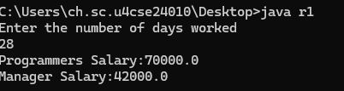

**Q no 2)**

**AIM:** to override to display the number of players in each game

**ALGORITHM:**

* 1. Start
  2. Define a base class games with a method show()
  3. Create three subclasses:
* cricket
* hockey
* football
  1. Override the show() method in each subclass to print "No of players: 11".
  2. Define a main method inside the r2 class.
  3. Create objects of cricket, hockey, and football classes.
  4. Call the show() method for each object.
  5. Print the number of players for each sport.
  6. End

**CODE:**

import java.util.Scanner;

class games{

void show(){

}

}

class cricket extends games{

@Override

void show(){

System.out.println("No of players:11");

}

}

class hockey extends games{

@Override

void show(){

System.out.println("No of players:11");

}

}

class football extends games{

@Override

void show(){

System.out.println("No of players:11");

}

}

public class r2{

public static void main(String[] args){

cricket c = new cricket();

hockey h = new hockey();

football f = new football();

c.show();

h.show();

f.show();

}

}

**OUTPUT:**

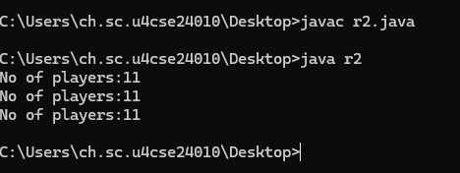

**Q no 3)**

**AIM:**

**ALGORITHM:**

**CODE:**

import java.util.Scanner;

class vehicle{

void speedup(int s){

}

}

class car extends vehicle{

@Override

void speedup(int s){

s=s+20;

System.out.println("Car Speed:"+s);

}

}

class bike extends vehicle{

@Override

void speedup(int s){

s=s+10;

System.out.println("bike speed"+s);

}

}

public class r3{

public static void main(String[] args){

Scanner obj = new Scanner(System.in);

System.out.println("Enter your current speed");

int s = obj.nextInt();

car c = new car();

bike b = new bike();

c.speedup(s);

b.speedup(s);

}

}

**OUTPUT:**

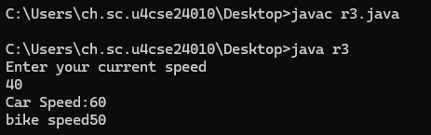

**Q no 4)**

**AIM**: To display the interest rate of an bank on the request of user

**ALGORITHM:**

Step 1: Start the program.

Step 2: Import the Scanner class from java.util to read user input.

Step 3: Define a base class Bank with a method getInterestrate() that returns 0.0.

Step 4: Create three subclasses SBI, ICICI, and RBI that extend Bank and override getInterestrate() to return their respective interest rates:

* SBI → 8.77%
* ICICI → 8.22%
* RBI → 8.00%

Step 5: In the main method:

* Create a Scanner object to take user input.
* Prompt the user to enter a bank name (SBI, ICICI, RBI).
* Read the bank name, convert it to uppercase to avoid case sensitivity.

Step 6: Use a switch-case to check the entered bank name:

* If the bank name is "SBI", create an instance of SBI.
* If the bank name is "ICICI", create an instance of ICICI.
* If the bank name is "RBI", create an instance of RBI.
* If the bank name is invalid, display "Invalid bank name" and exit the program.

Step 7: Call the getInterestrate() method on the selected bank object and display the interest rate.

Step 8: Close the Scanner object to free resources.

Step 9: End the program.

**CODE:**

import java.util.Scanner;

class Bank{

double getInterestrate(){

return 0;

}

}

class SBI extends Bank{

@Override

double getInterestrate()

{

return 8.77;

}

}

class ICICI extends Bank{

@Override

double getInterestrate(){

return 8.22;

}

}

class RBI extends Bank{

@Override

double getInterestrate(){

return 8.0;

}

}

public class m1{

public static void main(String[] args){

Scanner obj = new Scanner(System.in);

System.out.println("Enter your bank name");

String bankname = obj.nextLine().trim().toUpperCase();

Bank bank;

switch(bankname){

case "SBI":

bank = new SBI();

break;

case "ICICI":

bank = new ICICI();

break;

case "RBI":

bank = new RBI();

break;

default:

System.out.println("Inavlid bank name");

obj.close();

return;

}

System.out.println("Interest Rate is:"+bank.getInterestrate()+"%");

obj.close();

}

}

**OUTPUT:**

**5b) Overloading**

**Q no1)**

**AIM:** An Ecommerce application for payment

**ALGORITHM:**

Step 1: Start the program.

Step 2: Import the Scanner class from java.util to read user input.

Step 3: Define the Payment class with multiple makePayment() methods (Method Overloading):

* Cash Payment: Accepts a double amount and prints a cash payment message.
* Credit Card Payment: Accepts a String cardNumber and double amount, masks the card number, and prints a payment confirmation.
* UPI Payment: Accepts a String upiId, double amount, and String remarks, then prints a payment confirmation.
* UPI QR Payment: Accepts a double amount and String qrCodeData, then prints a payment confirmation.

Step 4: In the main method:

* Create a Scanner object to take user input.
* Create a Payment object to process payments.
* Display a menu for selecting the payment method:

markdown

CopyEdit

1. Cash

2. Credit Card

3. UPI

4. UPI via QR Code

* Prompt the user to enter an option (1-4).

Step 5: Use a switch-case to process the selected payment method:

* Case 1 (Cash Payment):
  + Ask for the amount.
  + Call makePayment(amount).
* Case 2 (Credit Card Payment):
  + Consume the newline left by nextInt().
  + Ask for the card number.
  + Ask for the amount.
  + Call makePayment(cardNumber, amount).
* Case 3 (UPI Payment):
  + Consume the newline left by nextInt().
  + Ask for the UPI ID.
  + Ask for the amount.
  + Consume newline after nextDouble().
  + Ask for remarks.
  + Call makePayment(upiId, amount, remarks).
* Case 4 (UPI QR Payment):
  + Consume the newline left by nextInt().
  + Ask for QR code data.
  + Ask for the amount.
  + Call makePayment(amount, qrCodeData).
* Default Case:
  + Print "Invalid option!" if the user enters an invalid number.

Step 6: Close the Scanner object.

Step 7: End the program.

**CODE:**

import java.util.Scanner;

class Payment {

    // Cash Payment

    public void makePayment(double amount) {

        System.out.println("Processing cash payment of ₹" + amount);

    }

    // Credit Card Payment

    public void makePayment(String cardNumber, double amount) {

        System.out.println("Processing credit card payment...");

        System.out.println("Card Number: **** **** **** " + cardNumber.substring(cardNumber.length() - 4));

        System.out.println("Amount: ₹" + amount);

    }

    // UPI Payment

    public void makePayment(String upiId, double amount, String remarks) {

        System.out.println("Processing UPI payment...");

        System.out.println("UPI ID: " + upiId);

        System.out.println("Amount: ₹" + amount);

        System.out.println("Remarks: " + remarks);

    }

    // UPI QR Payment

    public void makePayment(double amount, String qrCodeData) {

        System.out.println("Processing UPI payment via QR scan...");

        System.out.println("QR Code: " + qrCodeData);

        System.out.println("Amount: ₹" + amount);

    }

}

public class l1 {

    public static void main(String[] args) {

        Scanner scanner = new Scanner(System.in);

        Payment payment = new Payment();

        System.out.println("Choose payment method:");

        System.out.println("1. Cash");

        System.out.println("2. Credit Card");

        System.out.println("3. UPI");

        System.out.println("4. UPI via QR Code");

        System.out.print("Enter option (1-4): ");

        int option = scanner.nextInt();

        switch (option) {

            case 1:

                System.out.print("Enter amount: ");

                double cashAmount = scanner.nextDouble();

                payment.makePayment(cashAmount);

                break;

            case 2:

                scanner.nextLine(); // consume leftover newline

                System.out.print("Enter card number: ");

                String cardNumber = scanner.nextLine();

                System.out.print("Enter amount: ₹");

                double cardAmount = scanner.nextDouble();

                payment.makePayment(cardNumber, cardAmount);

                break;

            case 3:

                scanner.nextLine(); // consume leftover newline

                System.out.print("Enter UPI ID: ");

                String upiId = scanner.nextLine();

                System.out.print("Enter amount: ₹");

                double upiAmount = scanner.nextDouble();

                scanner.nextLine(); // consume newline

                System.out.print("Enter remarks: ");

                String remarks = scanner.nextLine();

                payment.makePayment(upiId, upiAmount, remarks);

                break;

            case 4:

                scanner.nextLine(); // consume leftover newline

                System.out.print("Enter QR code data: ");

                String qrCode = scanner.nextLine();

                System.out.print("Enter amount: ₹");

                double qrAmount = scanner.nextDouble();

                payment.makePayment(qrAmount, qrCode);

                break;

            default:

                System.out.println("Invalid option!");

        }

        scanner.close();

    }

}

**OUTPUT:**

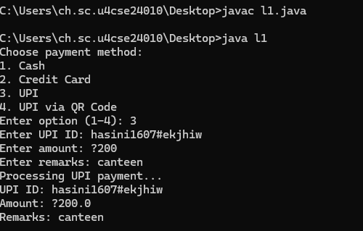

**Q no 2)**

**AIM:** To build a area calculator

**ALGORITHM:**

Step 1: Start the program.

Step 2: Import the Scanner class from java.util to read user input.

Step 3: Define the ShapeAreaCalculator class with method overloading for calculating the area of different shapes:

* Method 1 (Square): Accepts double side, calculates area = side × side, and prints the area.
* Method 2 (Rectangle): Accepts double length, double breadth, calculates area = length × breadth, and prints the area.
* Method 3 (Circle): Accepts double radius, boolean isCircle, checks if isCircle == true, calculates area = π × radius², and prints the area.

Step 4: In the main method:

* Create a Scanner object for user input.
* Create a ShapeAreaCalculator object for performing area calculations.
* Display a menu for selecting a shape:

markdown

1. Square

2. Rectangle

3. Circle

* Prompt the user to enter an option (1-3).

Step 5: Use a switch-case to process the selected shape:

* Case 1 (Square):
  + Ask the user to enter the side length.
  + Call calculateArea(side).
* Case 2 (Rectangle):
  + Ask the user to enter the length and breadth.
  + Call calculateArea(length, breadth).
* Case 3 (Circle):
  + Ask the user to enter the radius.
  + Call calculateArea(radius, true).
* Default Case:
  + Print "Invalid option!" if the user enters an invalid number.

Step 6: Close the Scanner object to free resources.

Step 7: End the program.

**CODE:**

import java.util.Scanner;

class ShapeAreaCalculator {

    // Area of square

    public void calculateArea(double side) {

        double area = side * side;

        System.out.println("Area of square: " + area + " sq. units");

    }

    // Area of rectangle

    public void calculateArea(double length, double breadth) {

        double area = length * breadth;

        System.out.println("Area of rectangle: " + area + " sq. units");

    }

    // Area of circle

    public void calculateArea(double radius, boolean isCircle) {

        if (isCircle) {

            double area = Math.PI * radius * radius;

            System.out.println("Area of circle: " + area + " sq. units");

        }

    }

}

public class l2 {

    public static void main(String[] args) {

        Scanner scanner = new Scanner(System.in);

        ShapeAreaCalculator calculator = new ShapeAreaCalculator();

        System.out.println("Choose shape to calculate area:");

        System.out.println("1. Square");

        System.out.println("2. Rectangle");

        System.out.println("3. Circle");

        System.out.print("Enter option (1-3): ");

        int option = scanner.nextInt();

        switch (option) {

            case 1:

                System.out.print("Enter side length of square: ");

                double side = scanner.nextDouble();

                calculator.calculateArea(side);

                break;

            case 2:

                System.out.print("Enter length of rectangle: ");

                double length = scanner.nextDouble();

                System.out.print("Enter breadth of rectangle: ");

                double breadth = scanner.nextDouble();

                calculator.calculateArea(length, breadth);

                break;

            case 3:

                System.out.print("Enter radius of circle: ");

                double radius = scanner.nextDouble();

                calculator.calculateArea(radius, true);

                break;

            default:

                System.out.println("Invalid option!");

        }

        scanner.close();

}

}

**OUTPUT:**

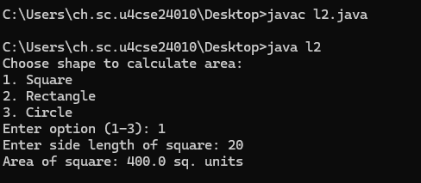

**Q no 3)**

**AIM**: Online shopping to calculate bill

**ALGORITHM:**

Step 1: Start

Step 2: Define the ShoppingCart class with three overloaded methods:

* Method 1: calculateBill(double price, int quantity) → Calculates total bill for a single item.
* Method 2: calculateBill(double[] prices) → Calculates total bill for multiple items.
* Method 3: calculateBill(double price, int quantity, double discount) → Calculates total bill after applying a discount.

Step 3: Implement calculateBill methods:

* For a single item:
  + Multiply price by quantity.
  + Print total bill.
* For multiple items:
  + Initialize total to 0.
  + Loop through the array of prices, adding each price to total.
  + Print total bill.
* For an item with a discount:
  + Multiply price by quantity to get total.
  + Calculate discount amount using (total * discount / 100).
  + Subtract discount amount from total.
  + Print final bill after discount.

Step 4: Define the ShoppingTest class with the main method:

* Create an instance of ShoppingCart.
* Call methods with different types of data:
  + Call calculateBill(price, quantity) for a single item.
  + Call calculateBill(prices[]) for multiple items.
  + Call calculateBill(price, quantity, discount) for an item with a discount.

Step 5: End

**CODE:**

class ShoppingCart {

// Total bill for a single item

public void calculateBill(double price, int quantity) {

double total = price * quantity;

System.out.println("Total bill: ₹" + total);

}

// Total bill for multiple items

public void calculateBill(double[] prices) {

double total = 0;

for (double price : prices) {

total += price;

}

System.out.println("Total bill for multiple items: ₹" + total);

}

// Total bill with discount

public void calculateBill(double price, int quantity, double discount) {

double total = price * quantity;

double discountAmount = total * (discount / 100);

double finalAmount = total - discountAmount;

System.out.println("Total bill after " + discount + "% discount: ₹" + finalAmount);

}

}

public class ShoppingTest {

public static void main(String[] args) {

ShoppingCart cart = new ShoppingCart();

cart.calculateBill(500, 2); // Single item

cart.calculateBill(new double[]{200, 300, 150}); // Multiple items

cart.calculateBill(1000, 2, 10); // Discounted bill

}

}

**OUTPUT:**

**Q no 4)**

**AIM:** Food delivery time calculator

**ALGORITHM:**

Step 1: Define the estimateTime method for distance-based delivery

1. Input: distance (double)
2. Compute time: time = 10 + (2 * distance)
3. Print: "Estimated Delivery Time: " + time + " minutes"

Step 2: Define the estimateTime method for distance with traffic condition

1. Input: distance (double), heavyTraffic (boolean)
2. Compute time: time = 10 + (2 * distance)
3. If heavyTraffic is true, add 5 minutes to time
4. Print: "Estimated Delivery Time (with traffic): " + time + " minutes"

Step 3: Define the estimateTime method for order type-based delivery

1. Input: distance (double), orderType (String)
2. Compute time: time = 10 + (2 * distance)
3. If orderType is "Fast", reduce time by 5 minutes
4. Print: "Estimated Delivery Time (" + orderType + " Delivery): " + time + " minutes"

Step 4: Execute the DeliveryTest class (main method)

1. Create an instance of DeliveryEstimator
2. Call estimateTime(5) → Distance-based estimation
3. Call estimateTime(5, true) → Distance with heavy traffic estimation
4. Call estimateTime(5, "Fast") → Distance with fast delivery estimation

**CODE:**

class DeliveryEstimator {

// Delivery time based on distance

public void estimateTime(double distance) {

double time = 10 + (2 * distance);

System.out.println("Estimated Delivery Time: " + time + " minutes");

}

// Delivery time with traffic conditions

public void estimateTime(double distance, boolean heavyTraffic) {

double time = 10 + (2 * distance);

if (heavyTraffic) {

time += 5;

}

System.out.println("Estimated Delivery Time (with traffic): " + time + " minutes");

}

// Delivery time based on order type (Fast or Normal)

public void estimateTime(double distance, String orderType) {

double time = 10 + (2 * distance);

if (orderType.equalsIgnoreCase("Fast")) {

time -= 5; // 5 min faster for fast delivery

}

System.out.println("Estimated Delivery Time (" + orderType + " Delivery): " + time + " minutes");

}

}

public class DeliveryTest {

public static void main(String[] args) {

DeliveryEstimator delivery = new DeliveryEstimator();

delivery.estimateTime(5); // Distance-based

delivery.estimateTime(5, true); // Distance with traffic

delivery.estimateTime(5, "Fast"); // Distance with fast delivery

}

}

**OUTPUT:**

**6 ) ABSTRACTION**

**6a) Using abstract classes**

**Q no 1)**

**AIM: To display online ticketing system**

**ALGORITHM:**

* + 1. Define an Abstract Class Ticket
* Declare a double price variable to store the base ticket price.
* Define an abstract method calculatePrice() to calculate the final price.
* Implement a method printTicket() to print the ticket price after calculation.
  + 1. Create a BusTicket Class (inherits Ticket)
* Define a constructor that initializes price using super(price).
* Implement the calculatePrice() method to return price * 1.05 (including a 5% tax).
  + 1. Create a TrainTicket Class (inherits Ticket)
* Define a constructor that initializes price using super(price).
* Implement the calculatePrice() method to return price * 1.10 (including a 10% tax).
  + 1. Create the Main Class (m1)
* Instantiate BusTicket with a base price of 100.
* Instantiate TrainTicket with a base price of 200.
* Call printTicket() for both objects to display final prices.
  + 1. Output the Calculated Ticket Prices
* Display the calculated ticket prices for both bus and train tickets with respective tax rates applied.

**CODE:**

abstract class Ticket {

double price;

Ticket(double price) {

this.price = price;

// Abstract method for price calculation

abstract double calculatePrice();

void printTicket() {

System.out.println("Ticket Price: $" + calculatePrice());

}

}

// Bus Ticket class

class BusTicket extends Ticket {

BusTicket(double price) {

super(price);

}

@Override

double calculatePrice() {

return price * 1.05; // 5% tax

}

}

// Train Ticket class

class TrainTicket extends Ticket {

TrainTicket(double price) {

super(price);

}

@Override

double calculatePrice() {

return price * 1.10; // 10% tax

}

}

// Main class

public class TicketBookingSystem {

public static void main(String[] args) {

Ticket busTicket = new BusTicket(100);

Ticket trainTicket = new TrainTicket(200);

System.out.println("Bus Ticket:");

busTicket.printTicket();

System.out.println("\nTrain Ticket:");

trainTicket.printTicket();

}

}

**OUTPUT:**

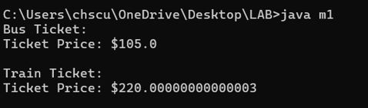

**Q no 2 )**

**AIM: To understand the abstract methods using pen abstract class and methods like**

**ALGORITHM:**

* 1. Define an Abstract Class pen
* Declare two abstract methods:
  + write(): To define the writing functionality.
  + refill(): To define the refilling functionality.
  1. Create a pics Class (inherits pen)
* Implement the write() method:
  + Print "Writing smoothly with a fountain pen".
* Implement the refill() method:
  + Print "refilling the ink".
  1. Create the Main Class (m1)
* Instantiate the pics class as an object p.
* Call the write() method to simulate writing with the pen.
* Call the refill() method to simulate refilling the ink.
  1. Output the Results
* Display messages indicating writing and refilling actions

**CODE:**

abstract class pen{

abstract void write();

abstract void refill();

}

class pics extends pen{

void write(){

System.out.println("Writing smoothly with a fountain pen");

}

void refill(){

System.out.println("refilling the ink");

}

}

public class m1{

public static void main(String []args){

pics p = new pics();

p.write();

p.refill();

}

}

**OUTPUT:**

**Q no 3)**

**AIM: Online exam**

ALGORITHM:

Question Management

User Authentication

Exam Delivery

Answer Processing

Scoring & Result Generation

CODING:

abstract class Question {

protected String questionText;

public Question(String questionText) {

this.questionText = questionText;

}

public abstract boolean checkAnswer(String answer);

public void displayQuestion() {

System.out.println("Question: " + questionText);

}

}

class MultipleChoiceQuestion extends Question {

private String[] options;

private String correctAnswer;

public MultipleChoiceQuestion(String questionText, String[] options, String correctAnswer) {

super(questionText);

this.options = options;

this.correctAnswer = correctAnswer;

}

@Override

public boolean checkAnswer(String answer) {

return correctAnswer.equalsIgnoreCase(answer);

}

public void displayOptions() {

for (int i = 0; i < options.length; i++) {

System.out.println((i + 1) + ". " + options[i]);

}

}

}

class TrueFalseQuestion extends Question {

private boolean correctAnswer;

public TrueFalseQuestion(String questionText, boolean correctAnswer) {

super(questionText);

this.correctAnswer = correctAnswer;

}

@Override

public boolean checkAnswer(String answer) {

return (correctAnswer && answer.equalsIgnoreCase("true")) || (!correctAnswer && answer.equalsIgnoreCase("false"));

}

}

public class java {

public static void main(String[] args) {

Question[] questions = new Question[2];

questions[0] = new MultipleChoiceQuestion("What is the capital of France?",

new String[]{"Berlin", "Madrid", "Paris", "Rome"},

"Paris");

questions[1] = new TrueFalseQuestion("The Earth is flat.", false);

for (Question question : questions) {

question.displayQuestion();

if (question instanceof MultipleChoiceQuestion) {

((MultipleChoiceQuestion) question).displayOptions();

}

String userAnswer = "Paris";

System.out.println("User answer: " + userAnswer);

System.out.println("Correct: " + question.checkAnswer(userAnswer));

System.out.println(); // Blank line between questions

}

}

}

OUTPUT:

**Q no 4)**

**AIM:** VOTING SYSTEM:

**ALGORITHM:**

1. Initialize an array of candidate names and a corresponding vote counter array.
2. Ask for number of voters.
3. Loop through each voter:
   * Prompt for candidate number.
   * Validate input and increment respective candidate’s vote.
4. Display total votes for each candidate.
5. Find and display the candidate with the highest votes.

**CODING:**

abstract class Voter {

protected String name;

protected int age;

public Voter(String name, int age) {

this.name = name;

this.age = age;

}

public abstract boolean isEligibleToVote();

public void displayVoterInfo() {

System.out.println("Name: " + name);

System.out.println("Age: " + age);

}

}

class CitizenVoter extends Voter {

public CitizenVoter(String name, int age) {

super(name, age);

}

@Override

public boolean isEligibleToVote() {

return age >= 18; // Eligible to vote if 18 or older

}

}

class NonCitizenVoter extends Voter {

public NonCitizenVoter(String name, int age) {

super(name, age);

}

@Override

public boolean isEligibleToVote() {

return false; // Non-citizens are not eligible to vote

}

}

public class VotingSystem {

public static void main(String[] args) {

Voter voter1 = new CitizenVoter("John Doe", 25);

Voter voter2 = new NonCitizenVoter("Jane Smith", 22);

voter1.displayVoterInfo();

if (voter1.isEligibleToVote()) {

System.out.println("This person is eligible to vote.");

} else {

System.out.println("This person is NOT eligible to vote.");

}

voter2.displayVoterInfo();

if (voter2.isEligibleToVote()) {

System.out.println("This person is eligible to vote.");

} else {

System.out.println("This person is NOT eligible to vote.");

}

}

}

**OUTPUT:**

**6b) Using interface**

**Q no 1 )**

**AIM:** shape area calculator

**CODE:**

// Shape.java

interface Shape {

double getArea();

}

// Circle.java

class Circle implements Shape {

double radius;

Circle(double radius) {

this.radius = radius;

}

public double getArea() {

return Math.PI * radius * radius;

}

}

// Rectangle.java

class Rectangle implements Shape {

double length, width;

Rectangle(double length, double width) {

this.length = length;

this.width = width;

}

public double getArea() {

return length * width;

}

}

// Main.java

public class Main {

public static void main(String[] args) {

Shape circle = new Circle(5);

Shape rectangle = new Rectangle(4, 6);

System.out.println("Circle Area: " + circle.getArea());

System.out.println("Rectangle Area: " + rectangle.getArea());

}

}

**OUTPUT:**

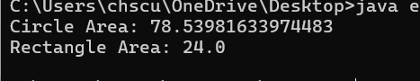

**Qno 2)**

**AIM:** applying the basic concepts through vehicle interface

**CODE:**

interface Vehicle {

void start();

void stop();

int getSpeed();

}

class Car implements Vehicle {

public void start() {

System.out.println("Car started.");

}

public void stop() {

System.out.println("Car stopped.");

}

public int getSpeed() {

return 80;

}

}

class Bike implements Vehicle {

public void start() {

System.out.println("Bike started.");

}

public void stop() {

System.out.println("Bike stopped.");

}

public int getSpeed() {

return 60;

}

}

public class VehicleTest {

public static void main(String[] args) {

Vehicle car = new Car();

Vehicle bike = new Bike();

car.start();

System.out.println("Car speed: " + car.getSpeed() + " km/h");

car.stop();

System.out.println();

bike.start();

System.out.println("Bike speed: " + bike.getSpeed() + " km/h");

bike.stop();

}

}

**OUTPUT:**

**Q no 3)**

**AIM:** Payment interface

**CODE:**

interface Payment {

void pay(double amount);

}

class CreditCard implements Payment {

public void pay(double amount) {

System.out.println("Paid ₹" + amount + " using Credit Card.");

}

}

class DebitCard implements Payment {

public void pay(double amount) {

System.out.println("Paid ₹" + amount + " using Debit Card.");

}

}

class UPIPayment implements Payment {

public void pay(double amount) {

System.out.println("Paid ₹" + amount + " using UPI.");

}

}

public class PaymentTest {

public static void main(String[] args) {

Payment p1 = new CreditCard();

Payment p2 = new DebitCard();

Payment p3 = new UPIPayment();

p1.pay(1000);

p2.pay(500);

p3.pay(250);

}

}

**OUTPUT:**

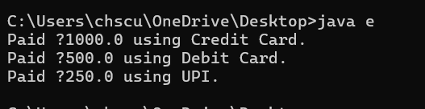

**Q no 4)**

**AIM**: multiple interface implementation

**CODE:**

// Printable.java

interface Printable {

void print();

}

// Scannable.java

interface Scannable {

void scan();

}

// PrinterScanner.java

class PrinterScanner implements Printable, Scannable {

public void print() {

System.out.println("Printing document...");

}

public void scan() {

System.out.println("Scanning document...");

}

}

public class e {

public static void main(String[] args) {

PrinterScanner device = new PrinterScanner();

device.print();

device.scan();

}

}

**OUTPUT:**

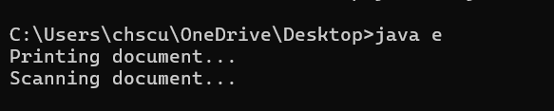

**7) ENCAPSULATION**

**Qno 1)**

**AIM**: To display the employee details privately

**ALGORITHM:**

• Start

• Create an Employee class with attributes

• Define a constructor to initialize values

• Define a displayDetails() method to show employee details

• In the Main class, create an Employee object with details

• Call displayDetails() method to print details

• Stop

**CODE:**

class Employee {

    private String name;

    private int age;

    private int id;

    private String designation;

    private String dob;

    private String doj;

    // Setter methods

    void setName(String n) {

        name = n;

    }

    void setAge(int a) {

        age = a;

    }

    void setId(int i) {

        id = i;

    }

    void setDesignation(String d) {

        designation = d;

    }

    void setDob(String d) {

        dob = d;

    }

    void setDoj(String d) {

        doj = d;

    }

    String getName() {

        return name;

    }

    int getAge() {

        return age;

    }

    int getId() {

        return id;

    }

    String getDesignation() {

        return designation;

    }

    String getDob() {

        return dob;

    }

    String getDoj() {

        return doj;

    }

}

public class Main {

    public static void main(String[] args) {

        Employee emp = new Employee();

        // Setting values without using 'this' or constructor

        emp.setName("Harsh");

        emp.setAge(19);

        emp.setId(51);

        emp.setDesignation("Fitter");

        emp.setDob("12.09.1977");

        emp.setDoj("12.06.1999");

        System.out.println("Employer's name: " + emp.getName());

        System.out.println("Employer's age: " + emp.getAge());

        System.out.println("Employer's id: " + emp.getId());

        System.out.println("Employer's Designation: " + emp.getDesignation());

        System.out.println("DOB: " + emp.getDob());

        System.out.println("DOJ: " + emp.getDoj());

    }

}

**OUTPUT:**

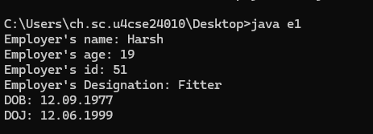

**Qno 2)**

**AIM:** Car renting System

**ALGORITHM:**

• **Start**

• **Create CarRental class**

* Define private attributes
* Create setter methods for carModel, rentalPrice, and availability
* Create getter methods for carModel, rentalPrice, and availability
* Create rentCar() method
* Create returnCar() method

• **Create Main class**

* Create an object of CarRental
* Set car details
* Display car details
* Rent the car
* Return the car

• **Stop**

**CODE:**

class CarRental {

    private String carModel;

    private double rentalPrice;

    private boolean isAvailable;

    // Setter methods

    void setCarModel(String model) {

        carModel = model;

    }

    void setRentalPrice(double price) {

        if (price > 0) {

            rentalPrice = price;

        } else {

            System.out.println("Rental price must be greater than zero.");

        }

    }

    void setAvailability(boolean available) {

        isAvailable = available;

    }

    // Getter methods

    String getCarModel() {

        return carModel;

    }

    double getRentalPrice() {

        return rentalPrice;

    }

    boolean getAvailability() {

        return isAvailable;

    }

    // Rent a car

    void rentCar() {

        if (isAvailable) {

            isAvailable = false;

            System.out.println(carModel + " has been rented.");

        } else {

            System.out.println(carModel + " is not available.");

        }

    }

    // Return a car

    void returnCar() {

        isAvailable = true;

        System.out.println(carModel + " has been returned.");

    }

}

// Main class

public class Main {

    public static void main(String[] args) {

        CarRental car = new CarRental();

        car.setCarModel("Toyota Corolla");

        car.setRentalPrice(50);

        car.setAvailability(true);

        System.out.println("Car Model: " + car.getCarModel());

        System.out.println("Rental Price: $" + car.getRentalPrice());

        System.out.println("Available: " + car.getAvailability());

        car.rentCar();

        car.returnCar();

    }

}

**OUTPUT:**

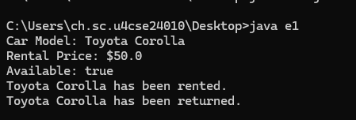

**Qno 3)**

**AIM**: Online course platform

**ALGORITHM:**

1. Start
2. Create Course class
   * Define private attributes
   * Create setter methods for course details
   * Create getter methods for course details
   * Create enrollStudent() method
   * Create dropStudent() method
3. Create Main class
   * Create an object of Course
   * Set course details
   * Display course details
   * Enroll a student
   * Drop a student
4. Stop

**CODE:**

class Course {

private String courseName;

private String courseId;

private String instructor;

private int maxStudents;

private int currentStudents;

// Setter methods

void setCourseName(String name) {

courseName = name;

}

void setCourseId(String id) {

courseId = id;

}

void setInstructor(String name) {

instructor = name;

}

void setMaxStudents(int max) {

if (max > 0) {

maxStudents = max;

}

}

void setCurrentStudents(int current) {

if (current >= 0 && current <= maxStudents) {

currentStudents = current;

}

}

// Getter methods

String getCourseName() {

return courseName;

}

String getCourseId() {

return courseId;

}

String getInstructor() {

return instructor;

}

int getMaxStudents() {

return maxStudents;

}

int getCurrentStudents() {

return currentStudents;

}

// Method to enroll a student

void enrollStudent() {

if (currentStudents < maxStudents) {

currentStudents++;

System.out.println("Student enrolled in " + courseName);

} else {

System.out.println("Course is full.");

}

}

// Method to drop a student

void dropStudent() {

if (currentStudents > 0) {

currentStudents--;

System.out.println("Student dropped from " + courseName);

}

}

}

public class e1 {

public static void main(String[] args) {

Course javaCourse = new Course();

javaCourse.setCourseName("Java Programming");

javaCourse.setCourseId("CS101");

javaCourse.setInstructor("Dr. Smith");

javaCourse.setMaxStudents(50);

javaCourse.setCurrentStudents(45);

System.out.println("Course Name: " + javaCourse.getCourseName());

System.out.println("Instructor: " + javaCourse.getInstructor());

javaCourse.enrollStudent();

javaCourse.dropStudent();

}

}

**OUTPUT:**

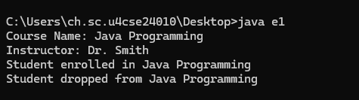

**Qno 4)**

**AIM:** Library management system

**ALGORITHM:**

• **Start**

• **Create LibraryBook class**

* Define private attributes
* Create setter methods for book details
* Create getter methods for book details
* Create borrowBook() method
* Create returnBook() method

• **Create Main class**

* Create an object of LibraryBook
* Set book details
* Display book details
* Borrow a book
* Return a book

• **Stop**

**CODE:**

class LibraryBook {

    private String bookId;

    private String title;

    private String author;

    private int availableCopies;

    // Setter methods

    void setBookId(String id) {

        bookId = id;

    }

    void setTitle(String bookTitle) {

        title = bookTitle;

    }

    void setAuthor(String bookAuthor) {

        author = bookAuthor;

    }

    void setAvailableCopies(int copies) {

        if (copies >= 0) {

            availableCopies = copies;

        }

    }

    // Getter methods

    String getBookId() {

        return bookId;

    }

    String getTitle() {

        return title;

    }

    String getAuthor() {

        return author;

    }

    int getAvailableCopies() {

        return availableCopies;

    }

    // Borrow a book

    void borrowBook() {

        if (availableCopies > 0) {

            availableCopies--;

            System.out.println("Book borrowed: " + title);

        } else {

            System.out.println("Book is not available.");

        }

    }

    // Return a book

    void returnBook() {

        availableCopies++;

        System.out.println("Book returned: " + title);

    }

}

// Main class

public class Main {

    public static void main(String[] args) {

        LibraryBook book = new LibraryBook();

        book.setBookId("B101");

        book.setTitle("Java Programming");

        book.setAuthor("James Gosling");

        book.setAvailableCopies(5);

        System.out.println("Book Title: " + book.getTitle());

        System.out.println("Author: " + book.getAuthor());

        book.borrowBook();

        book.returnBook();

    }

}

**OUTPUT:**

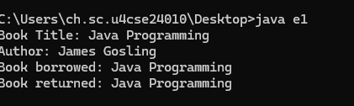

**8) PACKAGES**

**Q no 1)**

**AIM:** To find the median in an array list

**ALGORITHM:**

Step 1: Initialize Variables

1. Create an ArrayList<Integer> to store the numbers.
2. Create a Scanner object to take user input.

Step 2: Take Input from User

1. Prompt the user to enter the number of elements (n).
2. Read n from the user.
3. Prompt the user to enter n numbers.
4. Read each number and store it in the ArrayList.

Step 3: Sort the List

1. Use Collections.sort(numbers) to sort the list in ascending order.

Step 4: Find the Median

1. If n is even:
   * Compute the median as the average of the two middle numbers:

median=numbers[n2−1]+numbers[n2]2.0\text{median} = \frac{\text{numbers}[\frac{n}{2} - 1] + \text{numbers}[\frac{n}{2}]}{2.0}median=2.0numbers[2n​−1]+numbers[2n​]​

1. If n is odd:
   * Median is the middle element in the sorted list:

median=numbers[n2]\text{median} = \text{numbers}[\frac{n}{2}]median=numbers[2n​]

Step 5: Display Results

1. Print the sorted list.
2. Print the calculated median.

Step 6: Close Scanner

1. Close the Scanner to prevent resource leaks.

**CODE:**

import java.util.ArrayList;

import java.util.Collections;

import java.util.Scanner;

public class MedianFinder {

public static void main(String[] args) {

Scanner scanner = new Scanner(System.in);

ArrayList<Integer> numbers = new ArrayList<>();

System.out.print("Enter number of elements: ");

int n = scanner.nextInt();

System.out.println("Enter numbers:");

for (int i = 0; i < n; i++) {

numbers.add(scanner.nextInt());

}

// Sorting the list

Collections.sort(numbers);

// Finding median

double median;

if (n % 2 == 0) {

median = (numbers.get(n / 2 - 1) + numbers.get(n / 2)) / 2.0;

} else {

median = numbers.get(n / 2);

}

System.out.println("Sorted List: " + numbers);

System.out.println("Median: " + median);

scanner.close();

}

}

**OUTPUT:**

**Q no 2 )**

**AIM:** To count the number of words, lines and characters

**ALGORITHM:**

Step 1: Initialize Counters

1. Declare and initialize three counters:
   * charCount = 0 (to store the number of characters)
   * wordCount = 0 (to store the number of words)
   * lineCount = 0 (to store the number of lines)
2. Define the filename as "sample.txt".

Step 2: Open the File for Reading

1. Use a BufferedReader with a FileReader to read the file line by line.
2. If the file does not exist or an error occurs, handle it using a try-catch block.

Step 3: Read the File Line by Line

1. Start a loop to read each line from the file.
2. If the line is not null (i.e., there is still content in the file):
   * Increment lineCount by 1.
   * Add the length of the line to charCount (to count characters).
   * Split the line into words using split("\\s+") (to count words).
   * Increment wordCount by the number of words in the line.

Step 4: Display the Results

1. Print the total number of lines.
2. Print the total number of words.
3. Print the total number of characters.

Step 5: Handle Exceptions

1. If an IOException occurs, print an error message.

**CODE:**

public class p {

public static void main(String[] args) {

String filename = "sample.txt";

int charCount = 0, wordCount = 0, lineCount = 0;

try (BufferedReader reader = new BufferedReader(new FileReader(filename))) {

String line;

while ((line = reader.readLine()) != null) {

lineCount++;

charCount += line.length();

wordCount += line.split("\\s+").length;

}

System.out.println("Lines: " + lineCount);

System.out.println("Words: " + wordCount);

System.out.println("Characters: " + charCount);

} catch (IOException e) {

System.out.println("Error reading file: " + e.getMessage());

}

}

}

**OUTPUT:**

**Q no 3)**

**AIM:** To reverse set of words

**ALGORITHM:**

Step 1: Define a Function to Reverse Words

1. Input: A sentence (string).
2. Split the sentence into words using split("\\s+") (splitting based on spaces).
3. Initialize an empty StringBuilder to store the reversed sentence.

Step 2: Reverse the Order of Words

1. Iterate through the words array in reverse order (from last to first).
   * Append each word to the StringBuilder.
   * Add a space after each word.
2. Trim the final reversed sentence to remove the trailing space.

Step 3: Main Function Execution

1. Define a test sentence (e.g., "Hello World from Java").
2. Call the function reverseWords(sentence) to get the reversed sentence.
3. Print the original sentence.
4. Print the reversed sentence.

**CODE:**

public class p {

public static String reverseWords(String sentence) {

String[] words = sentence.split("\\s+");

StringBuilder reversed = new StringBuilder();

for (int i = words.length - 1; i >= 0; i--) {

reversed.append(words[i]).append(" ");

}

return reversed.toString().trim();

}

public static void main(String[] args) {

String sentence = "Hello World from Java";

System.out.println("Original: " + sentence);

System.out.println("Reversed: " + reverseWords(sentence));

}

}

**OUTPUT:**

**Q no 4)**

**AIM:** To read and write a file

**ALGORITHM:**

Step 1: Define the File Name

1. Set filename = "data.txt".

Step 2: Write Data to the File

1. Open the file using FileWriter in write mode.
2. Write the following text to the file:
   * "Hello, this is a test file!" (followed by a newline).
   * "Java File Handling Example."
3. Close the FileWriter automatically using a try-with-resources block.
4. If an error occurs, print "Error writing file" along with the error message.

Step 3: Read Data from the File

1. Open the file using BufferedReader with FileReader.
2. Read the file line by line:
   * Print each line to the console.
3. Close the BufferedReader automatically using a try-with-resources block.
4. If an error occurs, print "Error reading file" along with the error message.

**CODE:**

import java.io.*;

public class p {

public static void main(String[] args) {

String filename = "data.txt";

// Writing to the file

try (FileWriter writer = new FileWriter(filename)) {

writer.write("Hello, this is a test file!\n");

writer.write("Java File Handling Example.");

System.out.println("File written successfully!");

} catch (IOException e) {

System.out.println("Error writing file: " + e.getMessage());

}

// Reading from the file

try (BufferedReader reader = new BufferedReader(new FileReader(filename))) {

String line;

System.out.println("Reading from file:");

while ((line = reader.readLine()) != null) {

System.out.println(line);

}

} catch (IOException e) {

System.out.println("Error reading file: " + e.getMessage());

}

}

}

**OUTPUT:**

**9.FILE HANDLING**

**Q no 1)**

**AIM:** To write a file

**ALGORITHM:**

Step 1: Start  
Step 2: Try to execute the following steps (use try-catch for exception handling)  
Step 3: Create a FileWriter object and associate it with a file named "example.txt"  
Step 4: Write the text "hello everyone your safety our responsibility" into the file  
Step 5: Close the FileWriter to save the content and release resources  
Step 6: Print "File Written Successfully" if no error occurs  
Step 7: If an IOException occurs, catch the exception and print "An error occurred"  
Step 8: Print the stack trace of the exception for debugging  
Step 9: End

**CODE:**

import java.io.FileWriter;

import java.io.IOException;

public class e{

public static void main(String[] args){

try{

FileWriter writer = new FileWriter("example.txt");

writer.write("hello everyone your safety our responsibility");

writer.close();

System.out.println("File Written Successfully");

}

catch (IOException e){

System.out.println("An error occured");

e.printStackTrace();

}

}

}

**OUTPUT:**

**Q no 2)**

**AIM:** To read a file

**ALGORITHM:**

Step 1: Start  
Step 2: Use a try-catch block to handle potential exceptions  
Step 3: Create a File object pointing to "example.txt"  
Step 4: Create a Scanner object to read from the file  
Step 5: While there is another line to read in the file:

**CODE:**

import java.io.FileNotFoundException;

import java.util.Scanner;

public class e {

public static void main(String[] args) {

try {

File file = new File("example.txt");

Scanner reader = new Scanner(file);

while (reader.hasNextLine()) {

String data = reader.nextLine();

System.out.println(data);

}

reader.close();

} catch (FileNotFoundException e) {

System.out.println("File not found.");

e.printStackTrace();

}

}

}

**OUTPUT:**

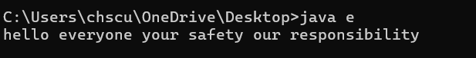

**Q no 3)**

**AIM: T**o append the contents in a file

**ALGORITHM:**

Step 1: Start  
Step 2: Use a try-catch block to handle exceptions  
Step 3: Create a FileWriter object for "example.txt" in append mode (i.e., true)  
Step 4: Use the write() method to append the text "\nThis line is appended." to the file  
Step 5: Close the FileWriter to save changes and release resources  
Step 6: Print "Content appended successfully." if no error occurs  
Step 7: If an IOException occurs:

**CODE:**

import java.io.FileWriter;

import java.io.IOException;

public class e {

public static void main(String[] args) {

try {

FileWriter writer = new FileWriter("example.txt", true); // true = append mode

writer.write("\nThis line is appended.");

writer.close();

System.out.println("Content appended successfully.");

} catch (IOException e) {

System.out.println("An error occurred.");

e.printStackTrace();

}

}

}

**OUTPUT:**

**Q no 4)**

**AIM:** To delete a file

**ALGORITHM:**

Step 1: Start  
Step 2: Create a File object and associate it with "example.txt"  
Step 3: Use the delete() method to attempt file deletion  
Step 4: If the file is successfully deleted:

* Print "Deleted the file: example.txt"  
  Step 5: Otherwise:
* Print "Failed to delete the file."  
  Step 6: End

**CODE:**

import java.io.File;

public class DeleteFile {

public static void main(String[] args) {

File file = new File("example.txt");

if (file.delete()) {

System.out.println("Deleted the file: " + file.getName());

} else {

System.out.println("Failed to delete the file.");

}

}

}

**OUTPUT:**

1. **EXCEPTION HANDLING**

**Q no 1)**

**AIM:**

To handle division by zero when calculating the average monthly balance in a banking application.

**ALGORITHM:**

1. Start
2. Declare totalBalance and months variables.
3. Use a try block to calculate totalBalance / months.
4. If months is zero, an ArithmeticException occurs.
5. Catch the exception and display an error message.
6. Continue program execution.
7. End

**CODING:**

public class BankingApp {

public static void main(String[] args) {

double totalBalance = 5000;

int months = 0; // This will cause a division by zero

try {

double avgBalance = totalBalance / months;

System.out.println("Average Monthly Balance: " + avgBalance);

} catch (ArithmeticException e) {

System.out.println("Error: Cannot divide by zero. Please enter a valid number of months.");

}

System.out.println("Banking system continues...");

}

}

**OUTPUT:**



**Q no 2)**

**AIM:**

To handle multiple exceptions such as ArrayIndexOutOfBoundsException and NullPointerException in an online shopping system.

**Algorithm:**

1. Start
2. Declare an array of items.
3. Assign an invalid index and a null value for testing.
4. Use a try block to access the array and get the length of the null item.
5. If an index is invalid, catch ArrayIndexOutOfBoundsException.
6. If an item is null, catch NullPointerException.
7. Continue program execution.
8. End

**CODING:**

public class OnlineShopping {

public static void main(String[] args) {

String[] items = {"Laptop", "Phone", "Headphones"};

int itemIndex = 5; // Invalid index

String selectedItem = null; // Simulating a null selection

try {

System.out.println("Selected Item: " + items[itemIndex]); // ArrayIndexOutOfBoundsException

System.out.println("Item Length: " + selectedItem.length()); // NullPointerException

} catch (ArrayIndexOutOfBoundsException e) {

System.out.println("Error: Item not found. Please select a valid item.");

} catch (NullPointerException e) {

System.out.println("Error: No item selected. Please choose an item.");

}

System.out.println("Shopping system continues...");

}

}

**OUTPUT:**

**Q no 3)**

**Aim:**

To use throws and finally for handling invalid passenger numbers in a flight booking system.

**Algorithm:**

1. Start

2. Define a method bookFlight(int passengers).

3. If passengers is less than or equal to 0, throw an exception.

4. Use a try block to call bookFlight().

5. Catch the exception and display an error message.

6. Use finally to ensure cleanup.

7. End

**CODE:**

public class bank {

// Step 2: Method that may throw an exception

public static void bookFlight(int passengers) throws IllegalArgumentException {

if (passengers <= 0) {

throw new IllegalArgumentException("Invalid number of passengers. Must be greater than 0.");

} else {

System.out.println("Flight booked successfully for " + passengers + " passengers.");

}

}

public static void main(String[] args) {

try {

// Step 4: Call the method inside try block

bookFlight(0); // Change this value to test valid/invalid cases

}

catch (IllegalArgumentException e) {

// Step 5: Catch and handle the exception

System.out.println("Booking Failed: " + e.getMessage());

}

finally {

// Step 6: Cleanup or final message

System.out.println("Thank you for using the Flight Booking System.");

       }

    }

}

**OUTPUT:**

**Q no 4)**

**Aim: ATM WITHRAWAL SYSTEM**

To implement an ATM withdrawal system with custom exception handling for invalid withdrawal amounts and insufficient balance.

Algorithm:

1. Start
2. Define a class InsufficientBalanceException (custom exception).
3. Define a class InvalidAmountException (custom exception).
4. Create a class ATM with a withdraw() method:
   * If the withdrawal amount is negative, throw InvalidAmountException.
   * If the withdrawal amount exceeds balance, throw InsufficientBalanceException.
   * Otherwise, deduct the amount and display the remaining balance.
5. Use a try-catch block in main() to handle exceptions.
6. End

CODING:

class InsufficientBalanceException extends Exception {

public InsufficientBalanceException(String message) {

super(message);

}

}

class InvalidAmountException extends Exception {

public InvalidAmountException(String message) {

super(message);

}

}

class ATM {

private double balance;

public ATM(double balance) {

this.balance = balance;

}

public void withdraw(double amount) throws InsufficientBalanceException, InvalidAmountException {

if (amount <= 0) {

throw new InvalidAmountException("Invalid amount! Please enter a positive value.");

}

if (amount > balance) {

throw new InsufficientBalanceException("Insufficient balance! You only have $" + balance);

}

balance -= amount;

System.out.println("Withdrawal successful! Remaining balance: $" + balance);

}

}

public class ATMSystem {

public static void main(String[] args) {

ATM atm = new ATM(5000); // Initial balance = $5000

try {

atm.withdraw(6000); // Exceeds balance → InsufficientBalanceException

} catch (InsufficientBalanceException | InvalidAmountException e) {

System.out.println("Exception: " + e.getMessage());

}

try {

atm.withdraw(-100); // Negative amount → InvalidAmountException

} catch (InsufficientBalanceException | InvalidAmountException e) {

System.out.println("Exception: " + e.getMessage());

}

try {

atm.withdraw(3000); // Valid withdrawal → Success

} catch (InsufficientBalanceException | InvalidAmountException e) {

System.out.println("Exception: " + e.getMessage());

}

}

OUTPUT:

